DAY 18: MORNING ASSESSMENT

1. What is React.js and who developed it?

React was developed by Jordan Walke, a software engineer at Facebook (now Meta), and was first released in 2013.

2. What is the difference between a React component and a regular JavaScript function?

A React component returns JSX (UI) and can manage state & lifecycle, while a regular JS function just runs code and returns values/data, not UI.

3. What is JSX and why is it used in React?

jsx is a syntax that lets you write HTML-like code inside JavaScript.

It’s used in React to make creating UI elements easier and more readable.

4.What is the difference between a functional component and a class component in React?  
 Functional components are simple JavaScript functions that return JSX, while class components are ES6 classes that extend React.Component and can use lifecycle methods.

5.What is the purpose of the return() statement inside a React component?  
 It tells React what UI (JSX) to render on the screen.

6.How do you display dynamic data (e.g., variables) inside JSX?  
 By wrapping the variable in curly braces, like {variableName}.

7.What is the difference between props and state in React?  
 Props are read-only and passed from parent to child, while state is managed within the component and can change over time.

8.What is the role of useState() in React functional components?  
 It lets you add and manage state inside a functional component.

9.What is the significance of the key attribute in React lists?  
 It helps React identify and efficiently update items when a list changes.

10.How do you handle events like button clicks in React?  
 By adding event handlers, for example:

<button onClick={handleClick}>Click</button>.

Coding questions

11.Display a variable value – Write a functional component that stores your name in a variable and displays it in <h1>.  
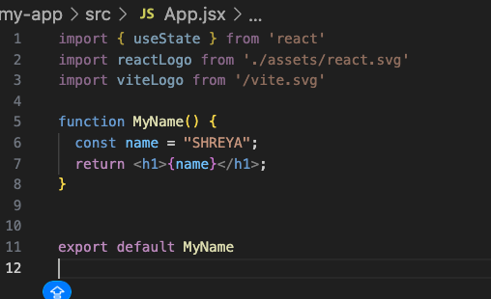

12.Add two numbers – Create a component that stores two numbers in variables and displays their sum.  
